1. Write a C program to perform factorial of a number
#include<stdio.h>
int main()
{
int i,n,f=1;
printf("\n enter n");
scanf("%d",&n);
for(i=1;i<=n;i++)
{
f=f*i;
i=i*1;
}
printf("\n factorial is %d",f);
return 0;
}
OUTPUT:
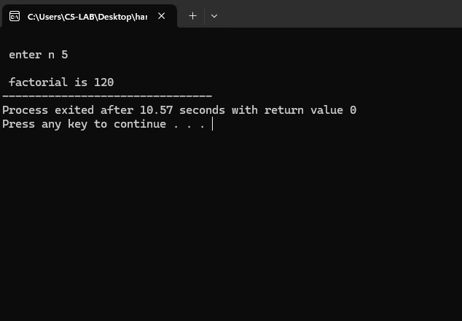

2. Write a C program to find the Sum of n natural numbers.
#include <stdio.h>
int main()
{
int i=1,sum=0,n;
printf("\n enter the value of n");
scanf("%d",&n);
while(i<=n)
{
sum=sum+i;
i=i+1;
}
printf("the sum of n num %d",sum);
return 0;
}
OUTPUT:
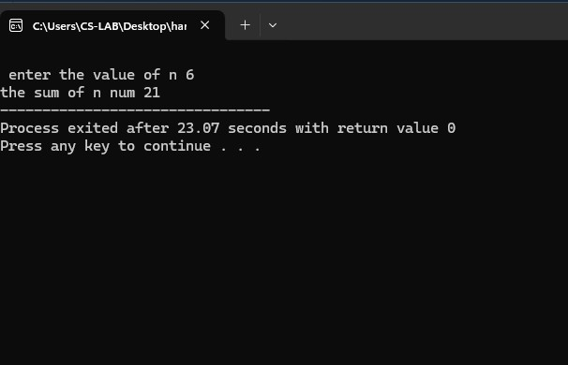
3. Write a C program to find the Sum of n digits.
#include<stdio.h>
int main()
{
int num,sum=0;
printf("\n enter number:");
scanf("%d",&num);
while(num!=0)
{
sum+= num%10;
num/= 10;
}
printf("sum of digits =%d\n",sum);
return 0;
}
OUTPUT:
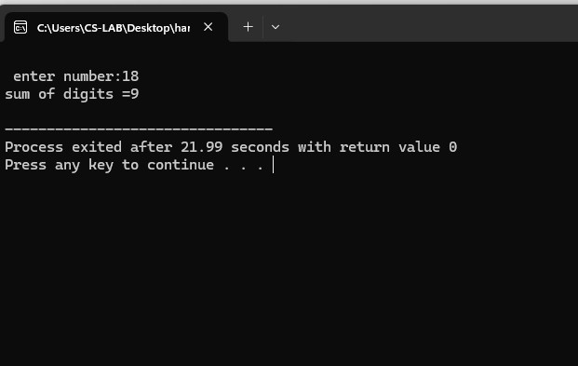
4. Write a C program to count the number of digits of a given number.
#include <stdio.h>
int main()
{
int num,count=0;
printf("enter the number :");
scanf("%d",&num);
while(num!=0)
{
count++;
num/=10;
}
printf("Digit =%d\n",count);
return 0;
}
OUTPUT:

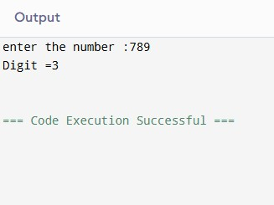
5. Write a C program to print all the even numbers between 1 to 10.
#include<stdio.h>
int main()
{
for(int i=2;i<=100;i+=2)
{
printf("%d \n” ,i);
}
return 0;
} OUTPUT:
}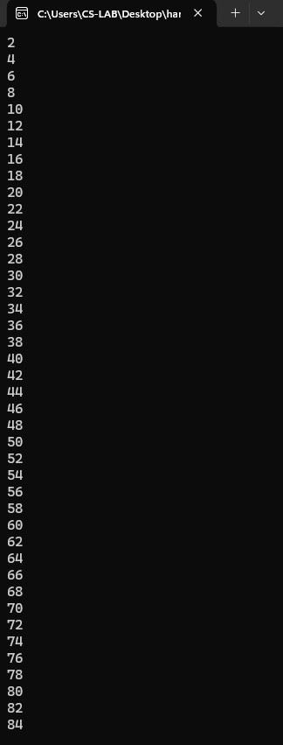
6. Write a C program to print the Fibonacci Series
#include<stdio.h>
int main()
{
int b=1,n,a=0,c;
printf("enter the number of terms:");
scanf("%d",&n);
printf("Fibonacci series:");
for(int i=1;i<=n;++i)
{
printf("%d \n",a);
c=a+b;
a=b;
b=c;
}
return 0;
}
OUTPUT:
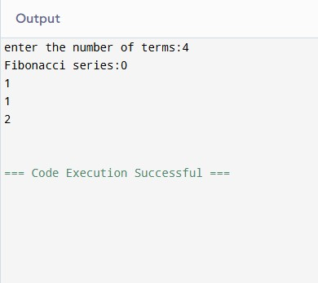
7.Write a C program to find the Reverse of a number
# include <stdio.h>
int main()
{
int num,rev=0,r;
printf("Enter an integer: ");
scanf("%d",&num);
while (num != 0)
{r=num%10;
rev= rev*10+r;
num =num/10;}
printf("Reversed number = %d\n",rev);
return 0;
}
OUTPUT:
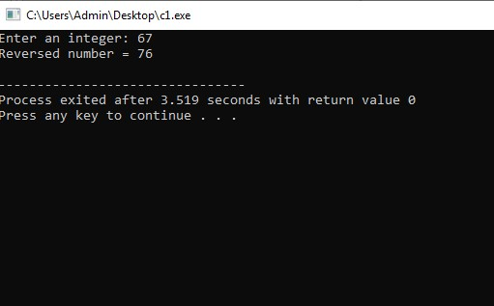
8. Write a C program to find the Maximum using Switch case.
#include <stdio.h>
int main()
{
int a,b;
int choice;
printf ("Enter two numbers:");
scanf ("%d%d",&a,&b);
choice=(a>b);
switch(choice)
{case 1:
printf("Maximum=%d\n",a);
break;
case 0:
printf("Maximum=%d\n",b);
break;
default:
printf("Both numbers are equal.");
break;
}
return 0;
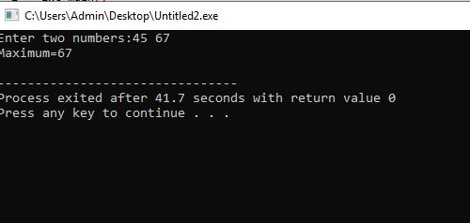
9.Write a C program for multiplication table.
#include <stdio.h>
int main()
{
int n;
printf(" Enter the number:");
scanf("%d",&n);
for(int i=1;i<=10;i++)
{printf ("\n %d*%d=%d",n,i,n*i);}
return 0;
}
OUTPUT:
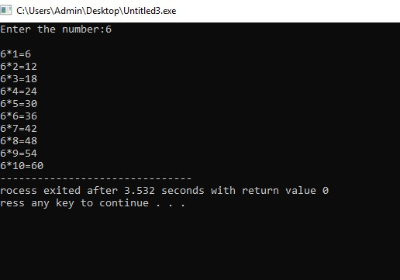

10.Write a menu driven program to perform arithmetic operations using Switch case.
#include <stdio.h>
int main()
{
int choice;
float num1, num2, result;
printf("Enter two numbers: ");
scanf("%f %f", &num1, &num2);
printf("\nChoose an operation:\n");
printf("1. Addition (+)\n");
printf("2. Subtraction (-)\n");
printf("3. Multiplication (*)\n");
printf("4. Division (/)\n");
printf("Enter your choice (1-4): ");
scanf("%d", &choice);
switch (choice)
{
case 1:
result = num1 + num2;
printf("Result: %.2f\n", result);
break;
case 2:
result = num1 - num2;
printf("Result: %.2f\n", result);
break;
case 3:
result = num1 * num2;
printf("Result: %.2f\n", result);
break;
case 4:
if (num2 != 0)
result = num1 / num2;
else {
printf("Division by zero!\n");
return 0;}
printf("Result: %.2f\n", result);
break;
default:
printf("Invalid choice!\n");}
return 0;
}
OUTPUT:
